Part Number: PT29A-24150-XX

Kit Contents
Item # | Quantity Reqd. | Description
1 | 1 | Rear Spoiler
2 | 2 | Trunk Lid Springs
3 | 1 | Hardware Bag
Hardware Bag Contents
Item # | Quantity Reqd. | Description
1 | 2 | M5 Assembly Nuts
2 | 2 | M5 Assembly Bolts
3 | 2 | Spacers
Additional Items Required For Installation
Item # | Quantity Reqd. | Description
1 | 1 | DIO Template  PT29A-24150-TL
2
3
Conflicts
RC F
Recommended Tools
Personal & Vehicle Protection | Notes
Safety Glasses
Blankets
Gloves
Masking Tape
Small Parts Tray
Special Tools | Notes
Spring Removal Tool | Optional
Installation Tools | Notes
Center punch
Drill Motor | ½” Chuck
Drill Bit | 8mm
Drill Stop | 8mm
Hole De-burring Tool
Ratchet
Socket | Magnetic 8mm Deep Well
Extensions | 6” & 3”
Torque Wrench | 0-100 lbf•in
Panel Clip Removal Tool | Panel Pry Tool # 1  Toyota SST 00002-06001-01
Shop Vacuum
Magnet w/ Flex Shaft
Special Chemicals | Notes
Simple Green All Purpose Cleaner or equivalent | ½ Strength
Sealant | 3M™ Ultra-Pro Body Sealant
General Applicability
RC and RC F-Sport
Recommended Sequence of Application
Item # | Accessory
1 | Rear Spoiler
2 | Cargo Net
3
*Mandatory
Vehicle Service Parts (may be required for reassembly)
Item # | Quantity Reqd. | Description
1 | 1 | Hardware Bag  (PT29A-24150-AB)
2 | 1 | Deck Lid Springs  (65776-24080)
Legend
STOP: Damage to the vehicle may occur. Do not proceed until process has been complied with.
OPERATOR SAFETY: Use caution to avoid risk of injury.
CAUTION: A process that must be carefully observed in order to reduce the risk of damage to the accessory/vehicle and to ensure a quality installation.
TOOLS & EQUIPMENT: Used in Figures calls out the specific tools and equipment recommended for this process.
REVISION MARK: This mark highlights a change in installation with respect to previous issue.
SAFETY TORQUE: This mark indicates that torque is related to safety.

Care must be taken when installing this accessory to ensure damage does not occur to the vehicle. The installation of this accessory should follow approved guidelines to ensure a quality installation.

These guidelines can be found in the "Accessory Installation Practices" document.

This document covers such items as:-
- Vehicle Protection (use of covers and blankets, cleaning chemicals, etc.).
- Safety (eye protection, rechecking torque procedure, etc.).
- Vehicle Disassembly/Reassembly (panel removal, part storage, etc.).
- Electrical Component Disassembly/Reassembly (battery disconnection, connector removal, etc.).

Please see your Toyota dealer for a copy of this document.

Prepare the Vehicle.
  - Installation of the rear spoiler should not take place until the following have been completed:
    - The car is washed.
    - The trunk and spoiler should be a minimum of 60˚F for proper set-up of adhesive tape. Use a hot air blower to heat the surface if the temperature is below 60˚F.
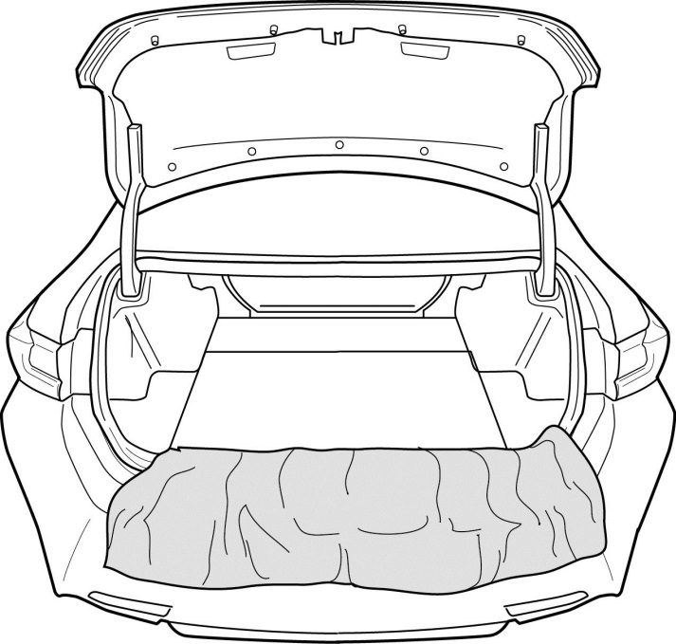
  - Open the trunk lid and place blankets to protect the rear fascia and the inner trunk area (Fig. 1-1).
Fig. 1-1

Remove the Trim Panels.
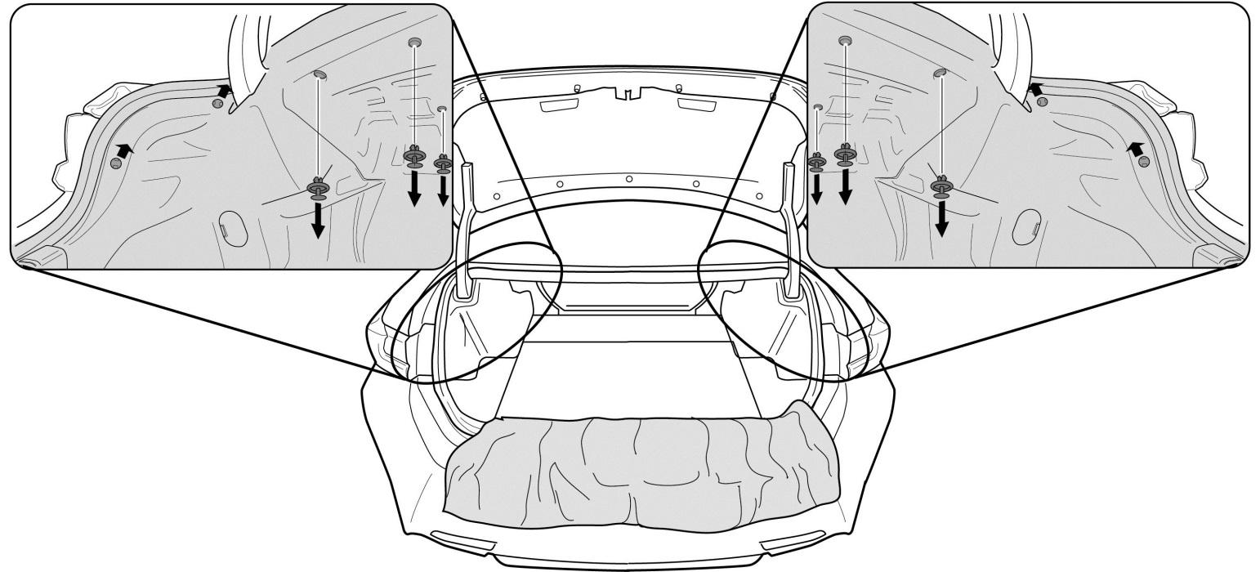
  - Remove the clips (Fig. 2-1).
Fig. 2-1

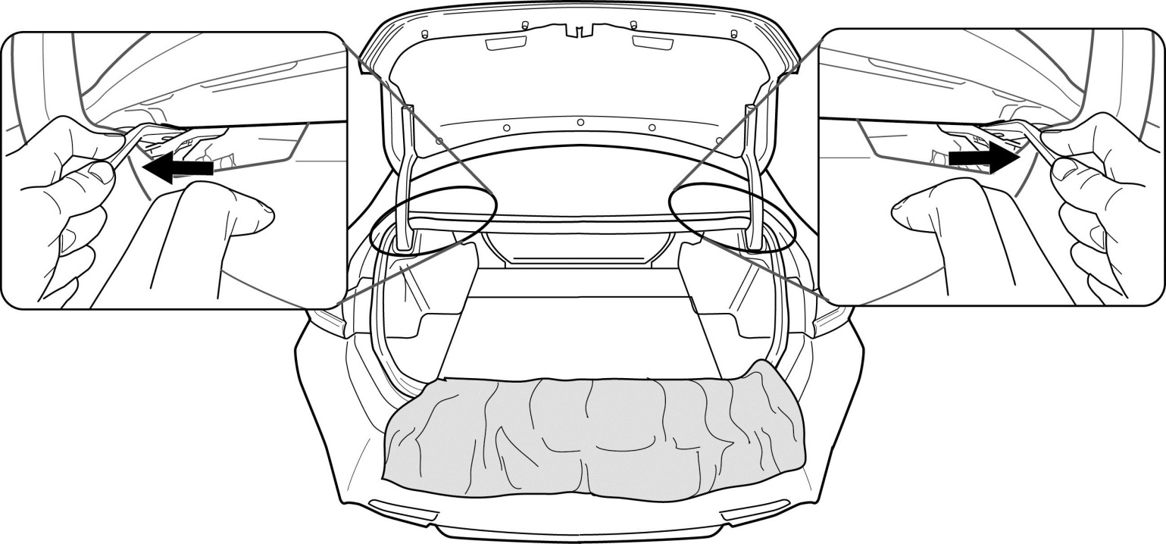
  - Remove the trim panels (Fig. 2-2).
Fig. 2-2

Replace the Trunk Lid Springs.
  - Prop the d lid or replace the assist springs one at a time (Fig. 3-1).
  - Remove the factory assist springs and discard them immediately (Fig. 3-1).
NOTE: The discarded springs are longer than the replacement spring.
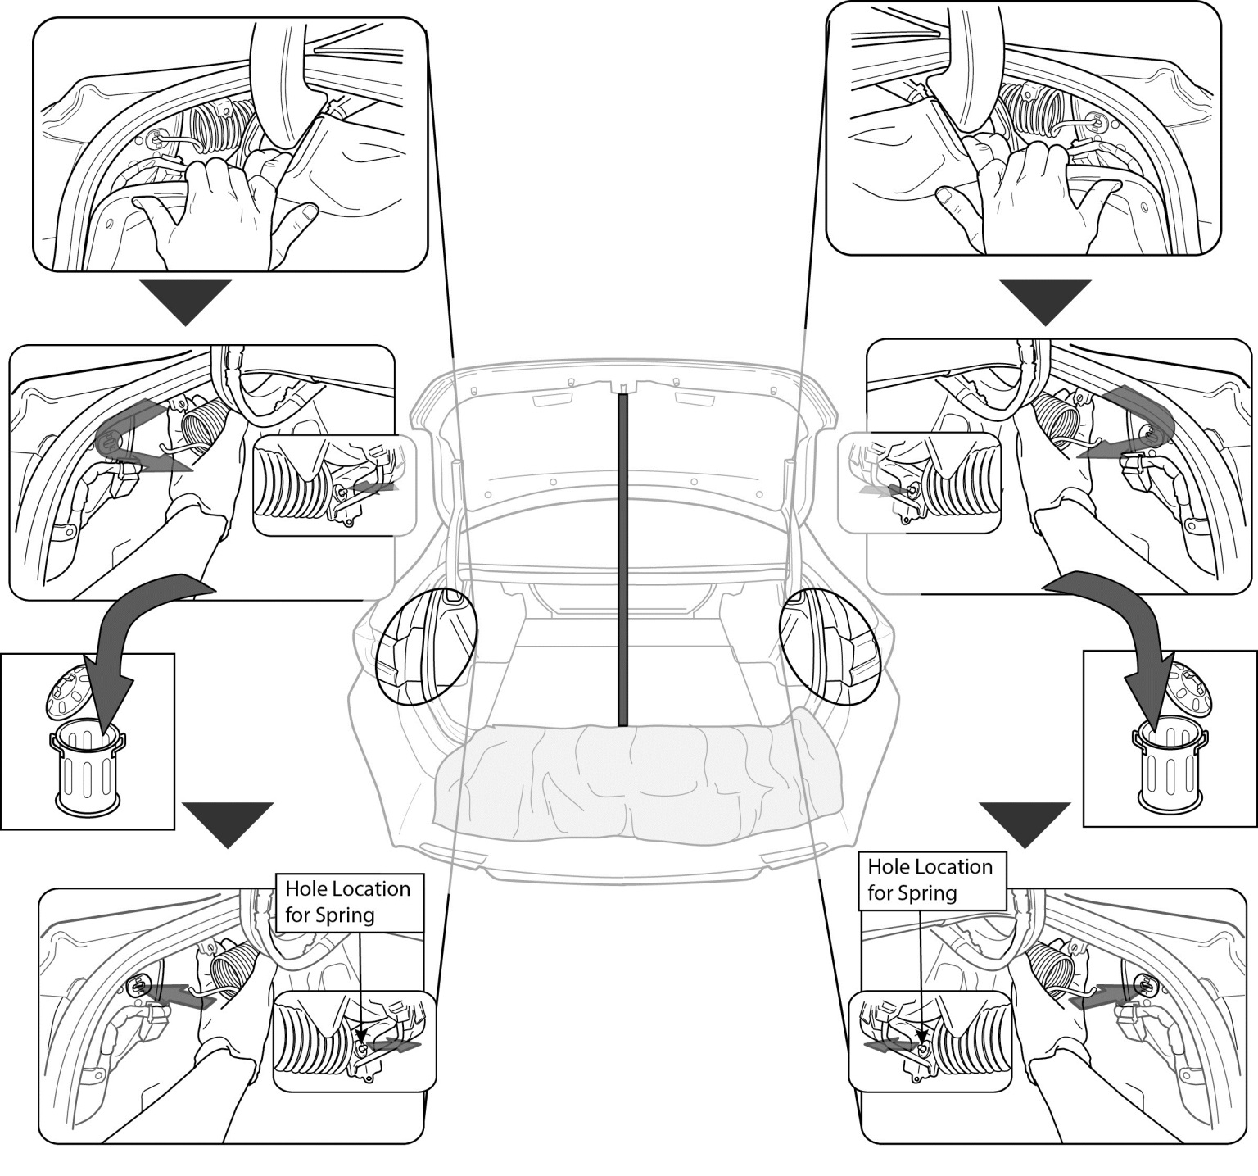
  - Install the supplied assist springs in the factory location (Fig. 3-1).
Fig. 3-1
Prop the Trunk Lid
Wear Gloves

Replace the Trim Panels.
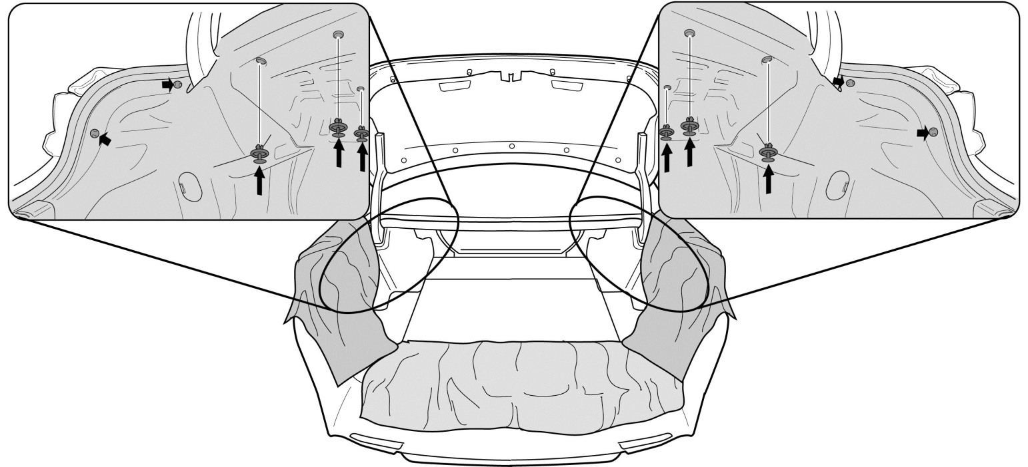
  - Replace the trim panels (Fig. 4-1).
Fig. 4-1
  - Replace the clips (Fig. 4-1).

Add Additional Vehicle Protection.
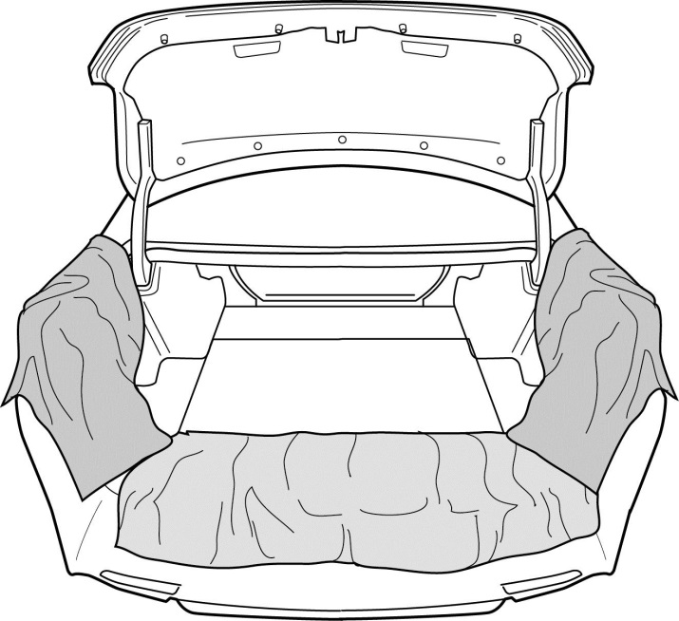
  - See Fig. 5-1.
Fig. 5-1

Remove the Trunk Lid Trim Panel.
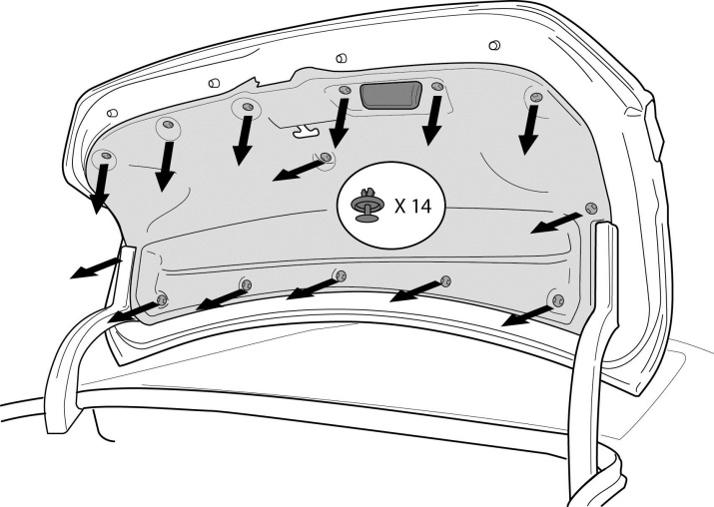
  - Use a trim removal tool to remove the 14 plastic clips securing the interior trunk lid liner to the trunk lid (Fig. 6-1).
Fig. 6-1
  - Remove the trim panel.

Drill the Mounting Holes.
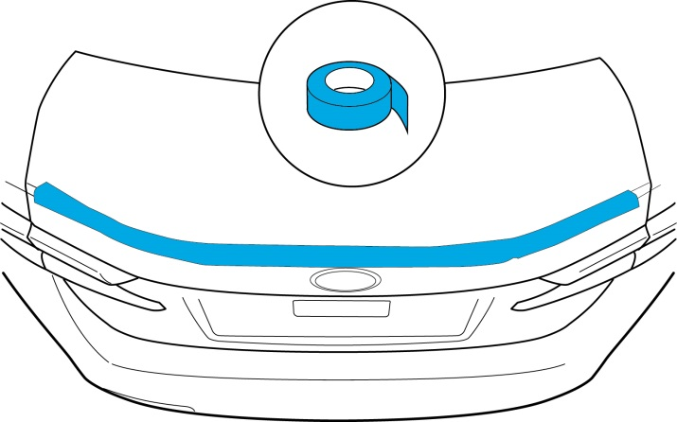
  - Place masking tape on the drilling area (Fig. 7-1).
Fig. 7-1

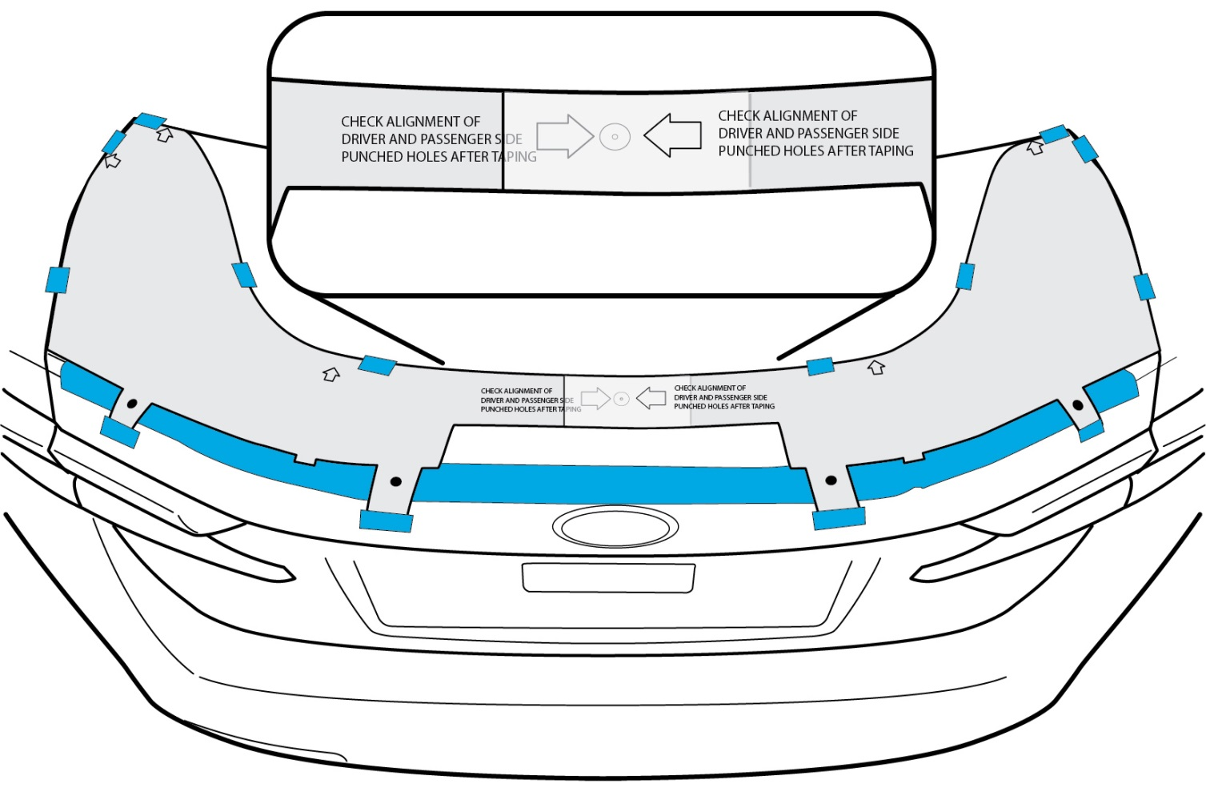
  - Tape the drilling template in place (Fig. 7-2).
Fig. 7-2
Note: Tabs not used for spoiler installation

NOTE: It is very important that the template does not have any wrinkles when it is positioned to ensure the holes are drilled in the proper location. The installation template should lay flat and tight against the vehicle surface.

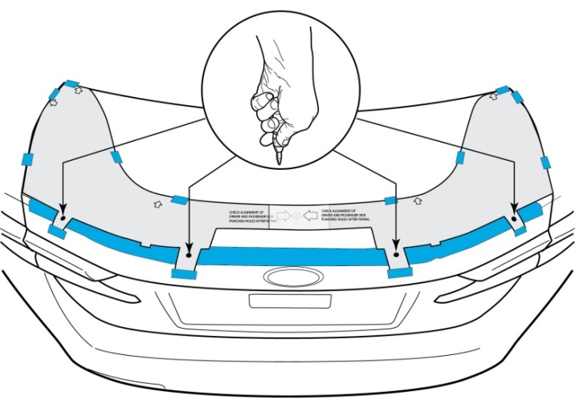
  - Center punch through the installation masking tape at each of the four cross hair locations (Fig. 2-5). This indentation in the masking tape will be used to accurately position the drill bit and prevent the drill bit from “walking” (Fig. 7-3).
Fig. 7-3
  - Remove the installation template carefully to ensure the tape does not damage the paint.
  - If desired, use the center punch to re-punch the hole locations to make the indentation “deeper". This will assist in preventing the drill bit from "walking.”
  - Apply additional tape around each center punched location to protect the paint if the drill bit slips.
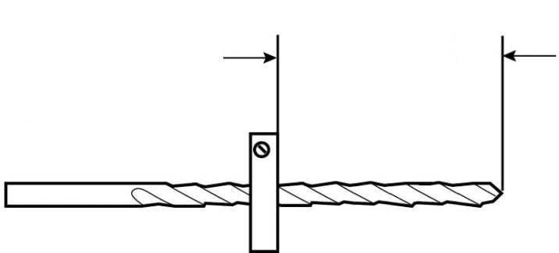
  - Set a drill stop to 25mm (Fig. 7-4) on both drill bits.
Fig. 7-4
25mm
3mm (1/8”) Pilot
8mm (5/16”) Final

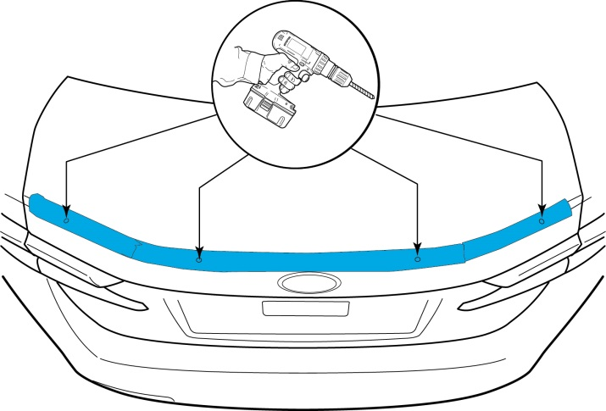
  - Drill a pilot hole at each center punched location with a 3mm (1/8”) drill bit (Fig. 7-5).
Fig. 7-5
CAUTION: Eye protection must be worn while drilling all holes.
  - Enlarge each drilled hole to 8mm (5/16”) (Fig. 7-5).

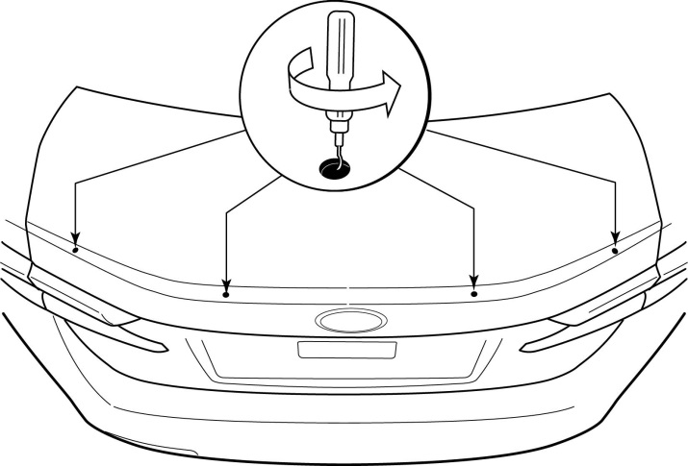
  - Remove the masking tape surrounding the holes and use a de-burring tool to remove any burrs on the edges of the four holes (Fig. 7-6).
Fig. 7-6

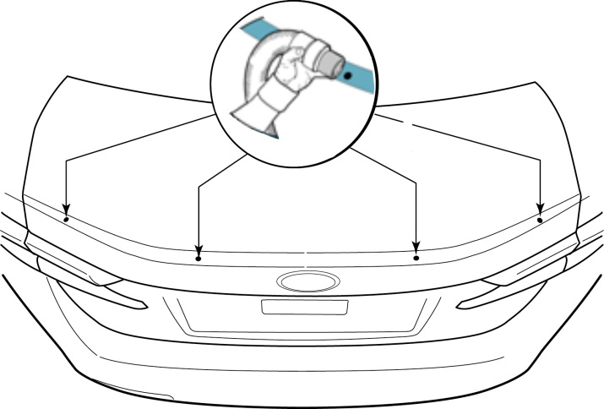
  - Vacuum the metal shavings from both sides of the trunk lid (Fig. 7-7).
Fig. 7-7

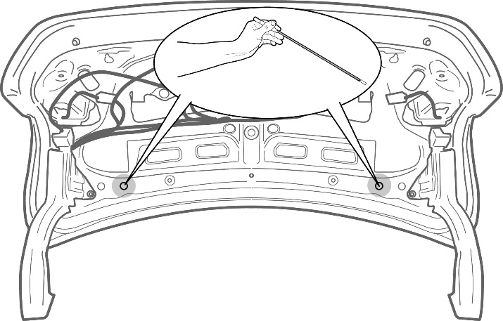
  - Open the deck lid and use a magnet with a flexible shaft to remove any remaining metal chips from the drilling process (Fig. 7-8).
Fig. 7-8
CAUTION: Use extreme care when inserting the magnetic tool into the deck lid to prevent pressure dents.

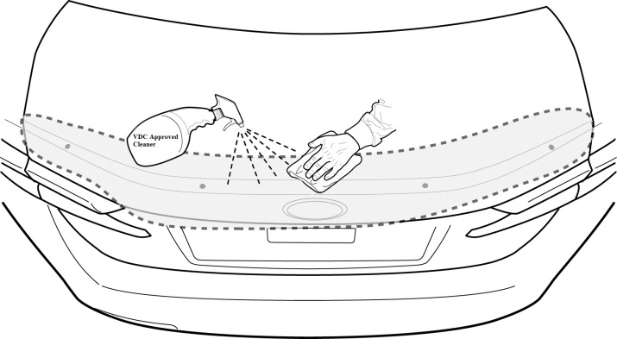
  - Clean the surface of the deck lid where the spoiler attaches with cleaner and a lint free cloth (Fig. 7-9).
Fig. 7-9

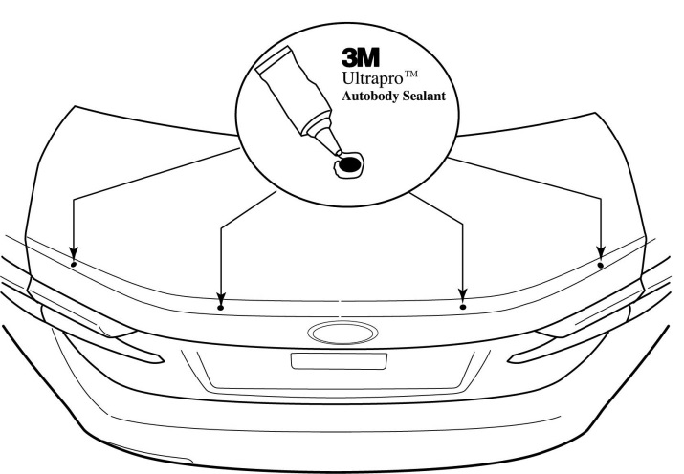
  - Apply 3M Ultra-Pro Body Sealant to the holes (Fig. 7-10).
Fig. 7-10

Install the Rear Spoiler.
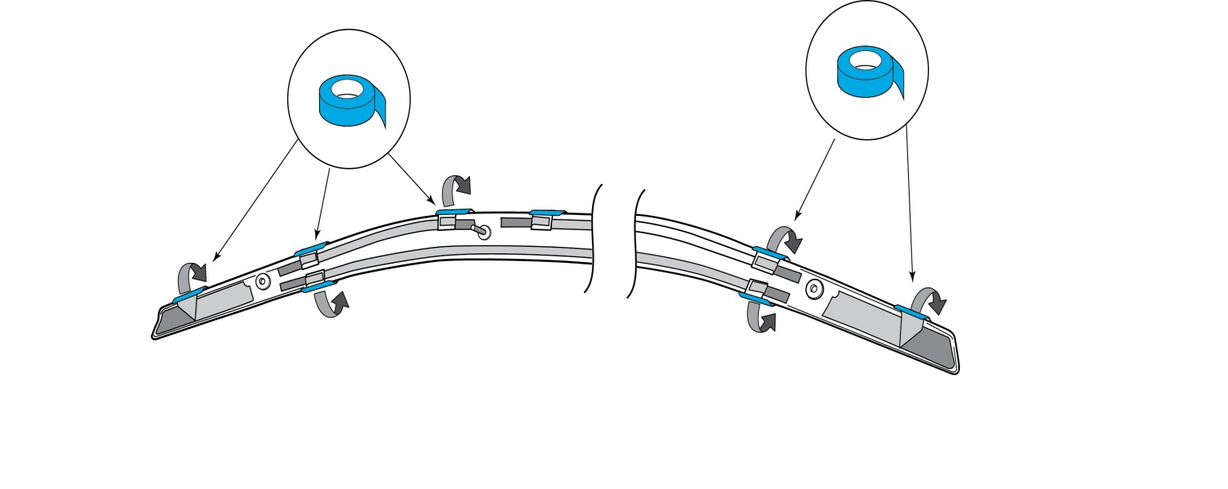
  - Peel the tape backing a short distance and add masking tape as tabs (Fig. 8-1).
Fig. 8-1

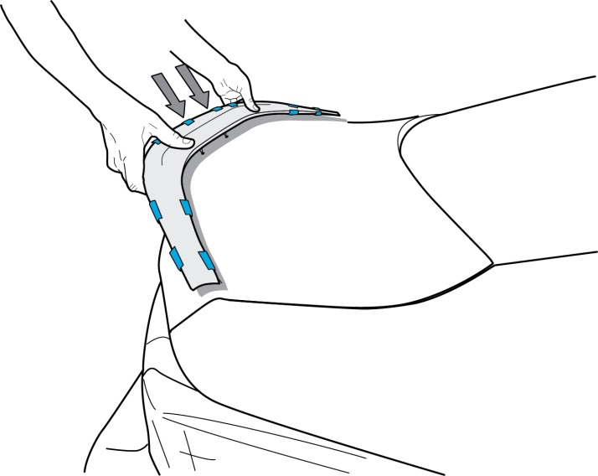
  - Place the spoiler on the trunk lid (Fig. 8-2).
Fig. 8-2

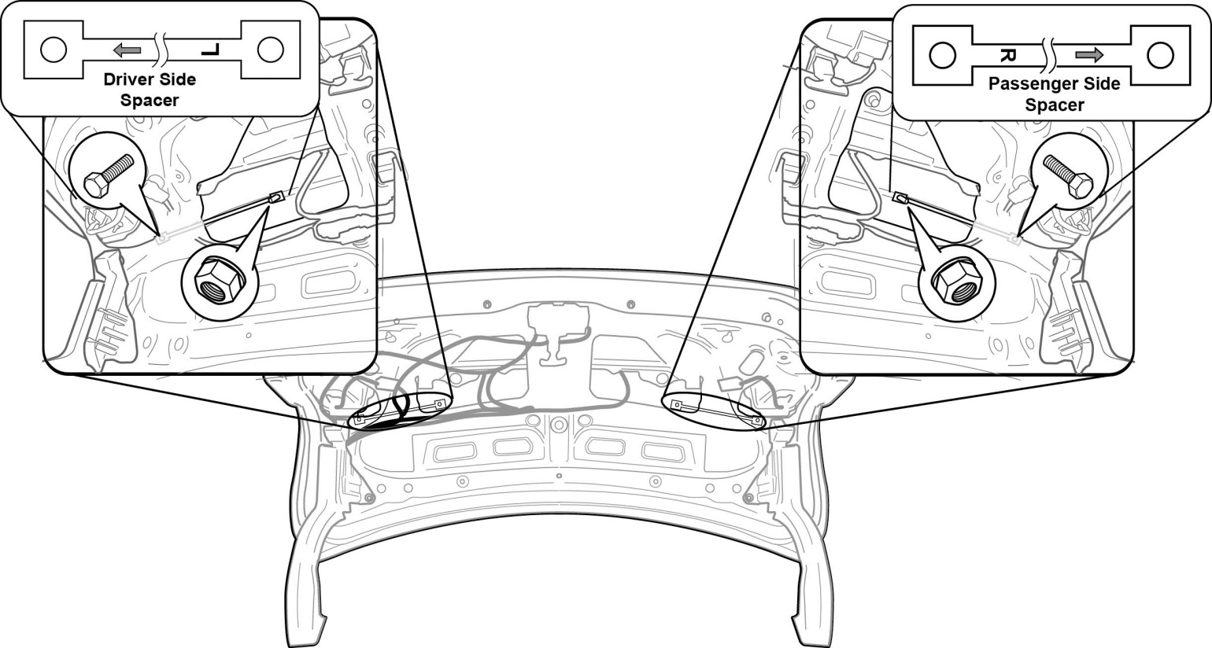
  - Loosely attach the spacers and hardware (Fig. 8-3).
Fig. 8-3

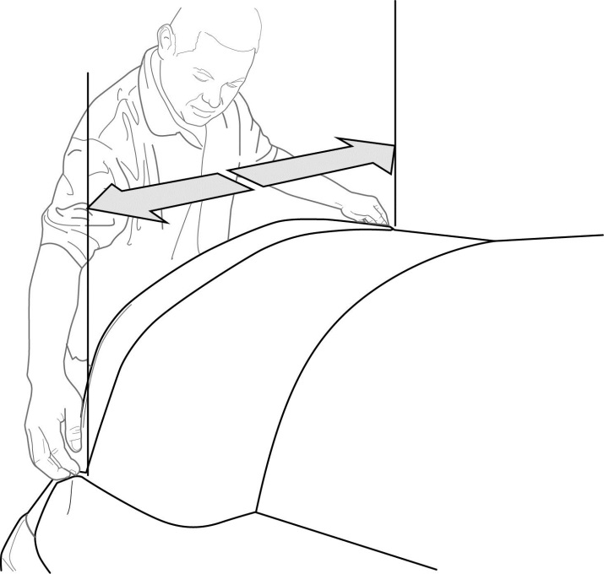
  - Center the spoiler on the deck lid so that the distance between the spoiler edge and the deck lid on each side is ±2mm at the ends (Fig. 8-4).
Fig. 8-4

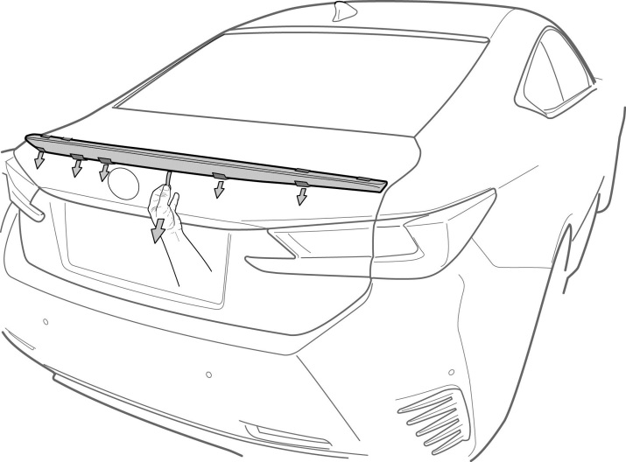
  - Remove the rear tape tabs (Fig. 8-5).
Fig. 8-5

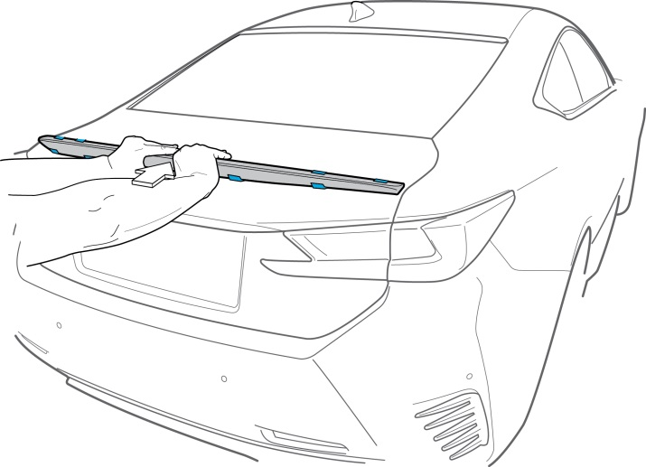
  - Apply forward pressure on the spoiler to ensure tape adhesion (Fig. 8-6).
Fig. 8-6

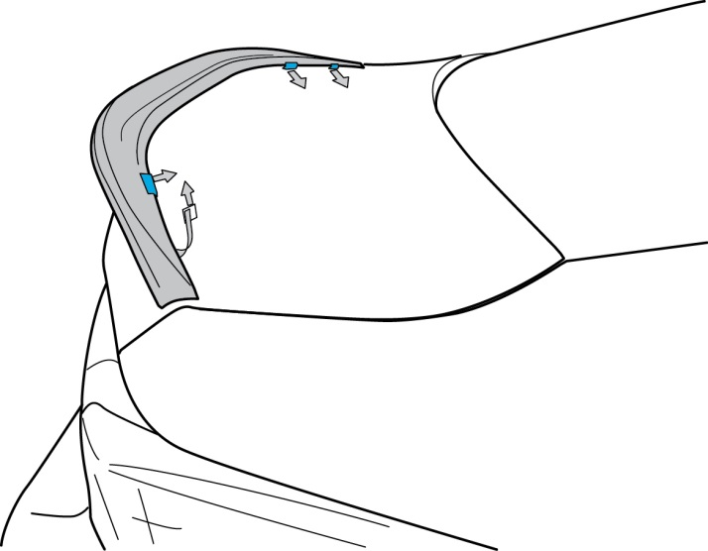
  - Remove the top tape tabs (Fig. 8-7).
Fig. 8-7

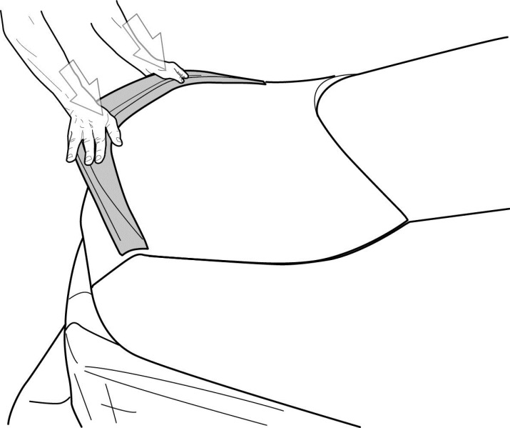
  - Apply downward pressure on the spoiler (Fig. 8-8).
Fig. 8-8

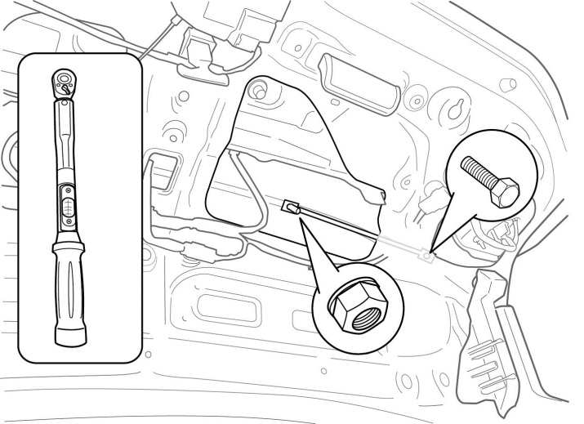
  - Tighten the attachment hardware (Fig. 8-9).
Fig. 8-9
Torque: 23 in-lbs

Reinstall the Trunk Lid Trim Panel.
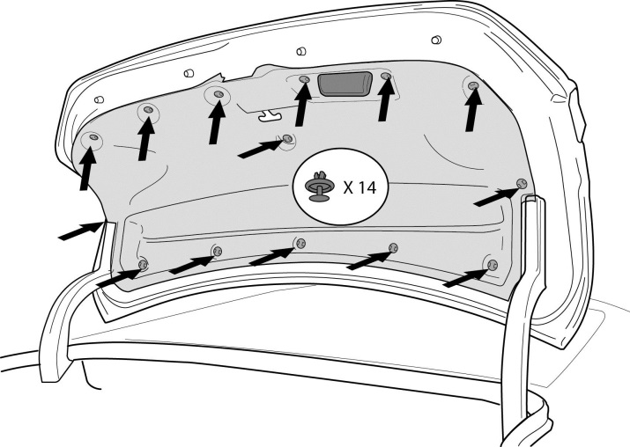
  - Reinstall the trunk lid trim panel (Fig. 9-1).
Fig. 9-1
  - Replace the 14 clips (Fig. 9-1).

Inspect the rear spoiler.
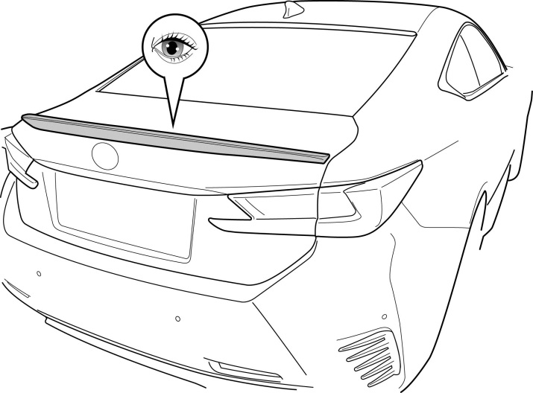
  - Check the rear spoiler for proper fitment (Fig. 10-1).
Fig. 10-1
  - Ensure the spoiler is centered left to right ± 2mm.
  - Ensure all adhesive is properly adhered with a maximum gap of 2mm.
  - Remove the poly wrap from the deck lid to inspect for pressure dents.

Accessory Function Checks
Verify acceptable gaps between spoiler attaching base and vehicle sheet metal
Check for visual alignment

Vehicle Function Checks
Verify trunk lid operation

Maximum gap of 3mm

Visibly centered, ±2mm

When opened, the trunk lid should initially pop up fully and remain in the fully raised position

Vehicle Appearance Check
After accessory installation and removal of protective cover(s), perform a visual inspection.

Ensure no damage (including scuffs and scratches) was caused during the installation process.
(For PPO installations, refer to TMS Accessory Quality Shipping Standard.)

